Claudia Goulet-Blais
40030249
PHOT 480

Independent Study Proposal

Research Topic and Objectives
A one-year Independent Study course is a great opportunity to dive into a research topic that has been a continued interest of mine for a few years now, but that I’ve only had a chance to examine cursorily. I would like to further research, through artistic creation and literary analysis, Mary Russo’s concept of the ‘female grostesque’. This concept deals with excess, expectations and risks in relation to gendered norms.
During my Large Format 1 course I created an image-based work called Regendering Clothing: A Series of Self-Portraits which introduced the beginning of this research topic where I was interested in deconstructing representations of femininity and masculinity through wardrobe. I embodied different identity codes referencing symbolism from 19th and 20th century paintings and photography. This Independent Study course will allow me to further research symbols, used over time in art histories, meant to question or claim identities. The topic of spatial concepts in relation to gender is a topic that I want to combine with the concept of the ‘female grotesque’. I want to completely reimage ways of how I can go about these topics. I am interested in continuing with self-portraiture, which is a recurring subject in my practice, where I aim to explore our perception of ourselves vs. how our identity is consumed and understood visually by others. I also want to explore still-life photography and installation-based work, which is still very new to me. I definitely intend to play with display, color and different mediums to engage with viewers, while keeping a focus on photography.
Workplan and Evaluation
Pascha Marrow was my professor for PHOT 300 and I found her feedback and attention to detail to be very helpful to my creative process. She has helped me develop my image-based work and elaborate on my concepts throughout the year. I am convinced that working with her, as my Independent Study supervisor, will help me achieve my research objectives and further develop my work. My Independent Study will include mid-term and end of semester critiques as mandatory and central evaluation landmarks. These presentation dates will be assigned by Pascha Marrow at the beginning of the Independent Study and I will meet with her throughout both semesters to work towards the progress of my research.
References

The recent exhibition About Face: Photographs by Cindy Sherman, Laurie Simmons and Rachel Harrison from the Collection of Carol and David Appel exhibition at the Montreal Museum of Fine Arts displayed self-portraits taken by Cindy Sherman that I had never seen before. These photographs were part of her Murder Mystery Series (1976-2000) and I found them to be very relevant to my research topic (fig. 1). I definitely consider this series as a source of inspiration for my Independent Study. As mentioned previously, Mary Russo’s ‘female grotesque’ concept is of interest to me and therefore I intend in reading more about Mary Russo’s point of view but also discovering other authors and artists who embrace this concept. I also find Liz Bondi, Professor of Social Geography to be a relevant reference to my research as she deals with the topic of ‘constructing gender’ as well as ‘Identity politics’. Professor of Political Science and Philosophy Seyla Benhabib has written about feminism in relation to social and cultural construction and I am planning on reading her essays on this topic.

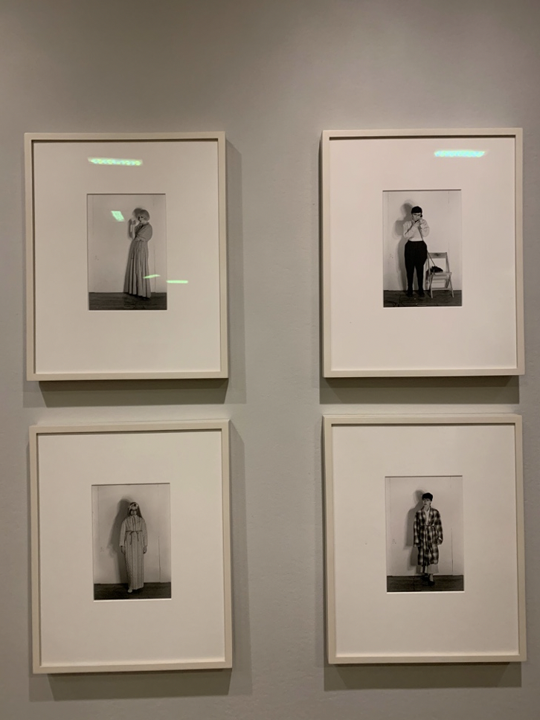
Figure 1. Photograph of Cindy Sherman’s Murder Mystery Series (1976-2000) taken at the About Face: Photographs by Cindy Sherman, Laurie Simmons and Rachel Harrison from the Collection of Carol and David Appel exhibition at the Montreal Museum of Fine Arts (Mbam).

